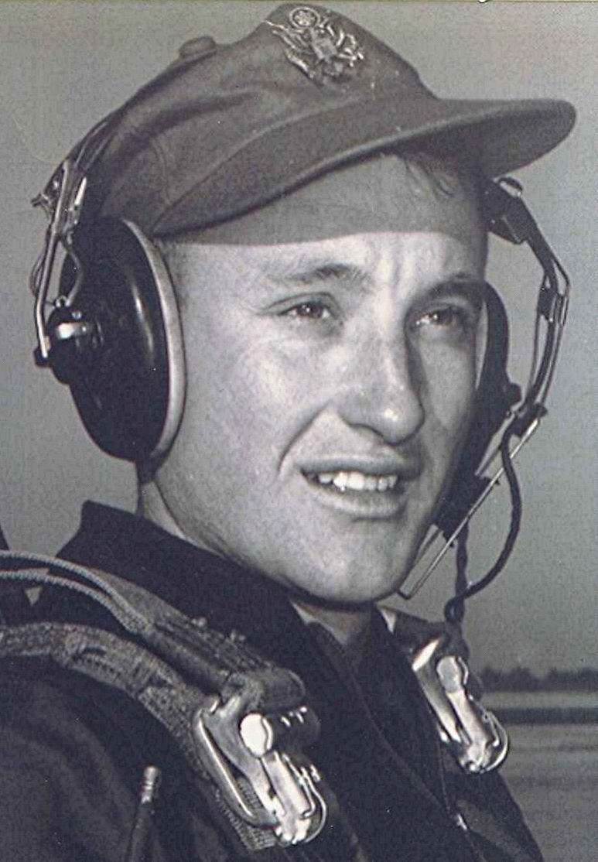
Far from home on a rainy day
Savannah, Georgia
September 10, 1989
Having just talked to Jane, my mind creates a scene of home, with the rain softly falling, the sky leaden and low, with wisps of fog touching the tops of the pecan trees in the corner of the field near the neighbor's house.
Soon it will be time for frost to fall and shortly after that, leaves will cascade down as the breezes shake them from their branches. Fall always had a special appeal to me as a child back on the farm. It was the harvest season, and I still re-live the wonderful sensation of how great it was to be alive at that special time of year. The mornings were cool, even cold, but by noon the sun's warmth felt pleasant on my back. Oftentimes, we were picking in the snowy fields of opened cotton. By the end of the day as the sun set, the tiredness soaked through every limb and muscle as the slight chillness of fall air settled over the fields awaiting nightfall. Then I would plunge headlong into the pile of loose cotton in the wagon, its softness and clean fragrance embracing me as I lay resting in a brief reverie.
I lost my sense of smell several years ago and since then, I find myself trying to re-create in my mind some of the many fragrances that accompanied fall. With that, I am acutely reminded of my inadequacies and limitations when I try to convey to another, my experiences, my thoughts, and sensations. I suppose the most depressing thing is to realize that I can never pass on to my children the experiences with which I was so abundantly blessed while on that farm.
Has it not been said that there is an innate sense within the elephant that causes it to return to a certain place to die? I have a relationship with that part of the earth which will remain with me till my last, dying breath. I am a product of that part of God's world and remember clearly the wonder I felt while roaming the pastures, woods, and fields. I stopped and studied the meanderings of an insect, or examined the beauty of a flower, all the while, filled with awe at the wondrous things that nature placed before me.
I sometimes reflect that I have come full circle; from farm to the world, and then, to the land. Could it be that Truth was back there, revealed to the boy who immersed himself in all the panoply and glory of rural life? I believe that, somehow, the small boy was closer to Truth there, than in the years to come. Although books have an incalculable value for stretching the limits of the mind, transferring the treasure of thought and enriching life, there are some things that transcend literature, letters, or expression. For a brief few years I was blessed with the unique opportunity to share with God his magnificent world, in a way that I will never again be able to revisit. For I know that yesteryear cannot be regained, having passed into history.
End

[Editor’s note: see “Richard Boyd Dodson 020.00 ~ 19890910 Savannah, Georgia” for a slightly different version of this same memory.]

